EXPLANATION ON THE AGENDA OF THE
ANNUAL GENERAL MEETING OF SHAREHOLDERS
AND
EXTRAORDINARY GENERAL MEETING OF SHAREHOLDERS (“EGMS”) OF
PT UNILEVER INDONESIA Tbk

With regard to the implementation plan of the Annual General Meeting of Shareholders and Extraordinary General Meeting of Shareholders (“Meeting”) of PT Unilever Indonesia Tbk (“Company”) on day/date Tuesday, 21 May 2019, the Company has announced through the newspapers namely Bisnis Indonesia and Investor Daily, the following matters:
- Announcement of the Meeting on 5 April 2019;
- Summon or Invitation to attend the Meeting on 22 April 2019.
Hereinafter, considering:

- Financial Service Authority Regulation (“POJK”) No. 32/POJK.04/2014 regarding the Planning and the Execution of Shareholders Meetings of the Public Company;
- Financial Service Authority Regulation (“POJK”) No. 33/POJK.04/2014 regarding the Board of Directors and Board of Commissioners of the Public Company;
- ASEAN Corporate Governance Scorecard issued by ASEAN Capital Market Forum related to the Right of Shareholder and principle of disclosure and transparency,
the Company hereby convey the Agenda of the Meeting as follows:
AGMS

First Agenda
Approval of the Financial Statement of the Company and approval of the Annual Report of the Company including the report on the supervisory duties of the Board of Commissioners of the Company for the accounting year ended on 31 December 2018
- Background
Refer to the provision of Article 10 and Article 11 of the Article of Association of the Company juncto Article 66, Article 67, Article 68 and Article 69, Law No. 40 Year 2017 regarding Limited Liability Company (“UUPT”)
2. Explanation
Annual Report of the Company for the accounting year ended 31 December 2018 including the supervisory report of the Board of Commissioners of the Company for financial year ended on 31 December 2018 and financial statement of the Company for the accounting year ended on 31 December 2018 which have been audited by Public Accountant Siddharta Widjaja & Rekan, member of KPMG member of KPMG as contained in the independent auditor’s report, dated 31 January 2019, number 00017/2.1005/AU.1/04/0847-2/1/I/2019 with fair result, in all material respects.
In this Agenda, the Company will propose to the Meeting to approve the Company’s annual report for the accounting year 2018 and to ratify the financial statements and reports of the supervisory duties of the Board of Commissioners of the Company for the accounting year 2018.
3. Data/Supporting Material
Annual Report of the Company 2018 can be downloaded from website of the Company. Further information please see https://www.unilever.co.id/investor-relations/publikasi-perusahaan/laporan-tahunan.html

Second Agenda
Determination of the appropriation of the profit of the Company
1. Background
Refer to the Article 20 paragraph 2 letter (b) and Article 25 of the Article of Association of the Company juncto Article 70 and Article 71 UUPT, the appropriation of the profit earned by the Company in a book year as stated in the balance sheet and income statement that has been authorized by Meeting will be used according to the use of net income by decision under Meeting’s resolution. The Company may distribute dividends if the Company has positive retained earnings, subject to the applicable provisions.
2. Explanation
The Company’s net profit for the accounting year ending 31 December 2018 is Rp 9,109,445,000,000 (nine trillion one hundred and nine billion four hundred and forty-five million Rupiah). The Company has distributed interim dividends in the amount of Rp 3,128,300,000,000 (three trillion one hundred twenty-eight billion three hundred million Rupiah) on 5 December 2018.
In this Agenda, the Company will propose to the Meeting to approve the use of the remaining net income of the Company after deducting the interim dividend for the accounting year ended on 31 December 2018.
3. Data/Supporting Material
Annual Report of the Company year 2018 can be downloaded in Company’s website. More information can be seen on https://www.unilever.co.id/investor-relations/publikasi-perusahaan/laporan-tahunan.html

Third Agenda
Approval of the proposal on the designation of a Public Accountant to audit the books of the Company for the accounting year ending on 31 December 2019 and determination of the honorarium of such Public Accountants and other terms of their designation
1. Background
Refer to Article 11 paragraph 2 letter (d) of the Article of Association of the Company juncto Article 68 UUPT, the Board of Directors of the Company is required to submit the financial statements to the public accountant appointed by the Meeting for reviewed.
Refer to Article 16 Paragraph 1 POJK No. 13/POJK.03/2017 concerning the Use of Public Accountant Services and Public Accounting Firms in Financial Services Activities, provides that the provision of audit services for the annual historical financial information to an entity by a Public Accountant is limited to a maximum of 3 (three) consecutive year books, where the Public Accountant of the Company’s financial statements for 1 (one) year consecutive accounting year, so that it can still be re-appointed.
2. Explanation
The Company proposes to the Shareholders to re-appoint Public Accountant Kartika Singodimejo, S.E., CPA with the permission of Public Accountant No. AP. 0847 from Public Accountant firm of Siddharta Widjaja & Rekan, member of KPMG, to audit/examination the books record of the Company for the accounting year ending on 31 December 2019.

3. Data/Supporting Material
Profile of Public Accountant firm can be downloaded at https://home.kpmg/id/en/home.html

Fourth Agenda
a. Approval on the proposed change in the composition of the Board of Directors and change in the composition of Board of Commissioners of the Company.
b. Determination of remuneration of the members of the Board of Directors and the Board of Commissioner of the Company for the accounting year ending on 31 December 2019
a. Approval on the proposed change in the composition of the Board of Directors and change in the composition of Board of Commissioners of the Company
1. Background
Refer to (i) provision of Article 3 and Article 23 POJK No. 33/POJK.04/2014 regarding the Board of Directors and Board of Commissioners of the Public Company and (ii) Article 19 paragraph 2 Article of Association of the Company provides that members of the Board of Directors/Board of Commissioners are appointed and dismissed by the Meeting. The appointment is to be effective on the date specified in the Meeting where he/they will be appointed and terminated at the closing of the third (3) Annual General Meeting of Shareholders after the date of their appointment.
2. Explanation
Mr. Vikas Gupta has been submitted his intention to resign from this Company. The Company in accordance with the recommendation of the Nomination Committee and Remuneration Committee will propose to the Meeting to appoint Mrs. Veronika Utami as the new Director of the Company.

The Company proposes to appoint Mrs. Sri Widowati as the new Director of the Company and Mrs. Debora Herawati Sadrach as the new Commissioner of the Company, to obtain approval from the Annual General Meeting of Shareholders to be held on 21 May 2019.

The company also proposed changing the position of Mr. Sancoyo Antarikso, who was originally an Independent Director to become the Company's Director effective since the closing of this Meeting.
b. Determination of remuneration of the members of the Board of Directors and the Board of Commissioner of the Company for the accounting year ending on 31 December 2019.
1. Background
Refer to Article 19 paragraph 6, Article 22 paragraph 5 of the Article of Association of the Company juncto Article 96 and Article 113 UUPT, Meeting may determine the amount of salary and allowances and/or income for members of the Board of Directors and salaries and/or honorarium and other allowances for members of the Board of Commissioners.
2. Explanation
In this Agenda, the Company will propose to the Meeting to approve as follows:
- To grant full power and authority to the President Commissioner of the Company to determine the honorarium for the members of the Board of Commissioners of the Company for the accounting year ending on 31 December 2019 and details of the allocation of shares to each member of the Board of Commissioners of the Company.
2. To grant full power and authority to the Board of Commissioners of the Company to determine the amount of remuneration of members of the Board of Directors of the Company for the accounting year ending on 31 December 2019 and details of the allocation of portion for each members of the Board of Directors of the Company
Additional Information
In addition to this explanation and detail information related to the mentioned above, please refer to information, data and documents that has been provided as follows:
Reference Link:
Profile / curriculum vitae of the candidate member of Commissioner | https://www.unilever.co.id/investor-relations/shareholder-information/berita-terkait-rups-dan-rupslb.html
Profile / curriculum vitae of the candidate member of Director | https://www.unilever.co.id/investor-relations/shareholder-information/berita-terkait-rups-dan-rupslb.html
Power of Attorney to attend the Meeting | https://www.unilever.co.id/investor-relations/shareholder-information/berita-terkait-rups-dan-rupslb.html

EGMS

First Agenda
Approval on the proposed change the Company’s business activities, in the form of adding new business fields, namely rental office space.
1. Background
In order to improve the Company’s performance going forward, the Company is engaged in industrial business, the field of large trade services (distributors) and import trade, marketing research (research) services and management consulting services, The Company sees business opportunities in the field of rental office space. The service is currently not one of the Company’s business fields. The Company has calculated carefully the business opportunities and services that can be run continuously, and the Company believes that the Company is able to take advantage of the opportunities, in order to provide added value to shareholders. Therefore, the Company plans to add its main business activities in the form of rental office space. The Company has disclosed information on this matter on 5 April 2019.
2. Explanation
In this agenda, the Company will submit to the EGMS to approve the plan to change the Company’s business activities, in the form of adding new business fields that is rental office space.

Mata Acara Kedua
Approval on the proposed change Article 3 Article of Association of the Company in connection with propose to increase the Company’s new business activities and editorial changes to the description of the Company’s business activities.

1. Background
The second agenda item will discuss the editorial changes in the description of the Company's business activities for the purpose of changing the Indonesian Standard Business Classification ("KBLUI") Code on the Legal Entity Administration System at the Ministry of Law and Human Rights of the Republic of Indonesia related to Electronic Integrated Licensing Services requirement.
2. Explanation
In this agenda, the Company will propose to the EGM to approve the editorial changes in the description of the Company's business activities for the purpose of changing the Indonesian Standard Business Classification ("KBLUI") Code on the Legal Entity Administration System at the Ministry of Law and Human Rights of the Republic of Indonesia related to Electronic Integrated Licensing Services requirement.
Meeting Location
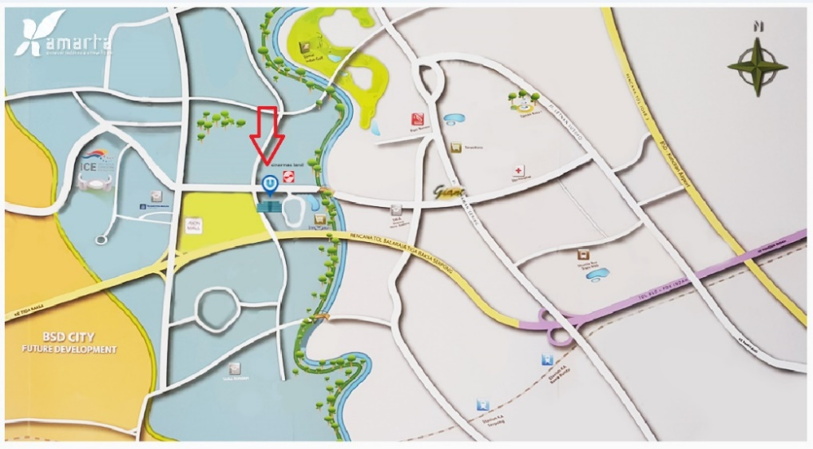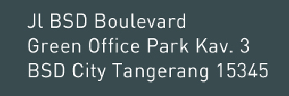
Schedule of Shuttle Bus:
Pick Up Point |  |  | Time | Pick Up Point
Morning Session
1. | Rawabuntu – Grha Unilever |  | 9:15 | At the front of STIKBA, approximately 20m to the nearest gas station
 |  |  | 9:30
 |  |  | 9:45
Afternoon Session
2. | Grha Unilever - Rawabuntu |  | 11:30 | At the front of Grha Unilever – East Lobby head to Rawa Buntu Station
 |  |  | 11:45
 |  |  | 12:00

Tangerang, 22 April 2019
PT Unilever Indonesia Tbk
Board of Directors

