EXPLANATION ON THE AGENDA OF THE
EXTRAORDINARY GENERAL MEETING OF SHAREHOLDERS OF
PT UNILEVER INDONESIA Tbk

With regard to the implementation plan of the Extraordinary General Meeting of Shareholders (“Meeting”) of PT Unilever Indonesia Tbk (“Company”) on day/date Wednesday, 20 November 2019, the Company has announced through the newspapers namely Bisnis Indonesia and Investor Daily, the following matters:
- Announcement of the Meeting on 7 October 2019;
- Summon or Invitation to attend the Meeting on 22 October 2019.
Hereinafter, considering:
- Financial Service Authority Regulation (“POJK”) No. 32/POJK.04/2014 regarding the Planning and the Execution of Shareholders Meetings of the Public Company;
- Financial Service Authority Regulation (“POJK”) No. 33/POJK.04/2014 regarding the Board of Directors and Board of Commissioners of the Public Company;
- ASEAN Corporate Governance Scorecard issued by ASEAN Capital Market Forum related to the Right of Shareholder and principle of disclosure and transparency,
the Company hereby convey the Agenda of the Meeting as follows:

First Agenda
Approval on the changes and appointment of the composition of the Board of Directors of the Company
Approval on the proposed change the composition of the Board of Directors of the Company
1. Background
Refer to (i) provision of Article 3 and Article 23 POJK No. 33/POJK.04/2014 regarding the Board of Directors and Board of Commissioners of the Issuer of Public Company and (ii) Article 19 paragraph 2 Article of Association of the Company provides that members of the Board of Directors/Board of Commissioners are appointed and dismissed by the Meeting. The appointment is to be effective on the date specified in the Meeting where he/they appointed and terminated at the closing of the third (3) Annual General Meeting of Shareholders after the date of their appointment.

2. Explanation
a. Ibu Amparo Cheung Aswin has been submitted her intention to resign from the Company. This is in accordance with the recommendation of the Nomination Committee and Remuneration Committee will propose to the Meeting to appoint Mr. Rizki Raksanugraha as the new Director of the Company.
b. Bapak Vikram Kumaraswamy has been submitted his intention to resign from the Company. This is in accordance with the recommendation of the Nomination Committee and Remuneration Committee will propose to the Meeting to appoint Mr. Arif Hudaya as the new Director of the Company.

Second Agenda
Approval on the proposed change of the nominal value of the Company’s share (Stock Split) and amendment to Article 4 of the Articles of Association of the Company caused by the Stock Split.

1. Background
The Company as a company engaged in industrial business, wholesale trade (distributor) and import trade, marketing research and management consulting services, proposes a change to the nominal value of the Company's shares from what was originally worth IDR10 henceforth be changed to IDR2 per share. Henceforth, on planned activities of stock split The Company needs to amend and adjust Article 4 of the Company's Articles of Association as a result of these Stock Split. Stock Split initiated by the Company in order to increase the liquidity of the Company's stock trading in the capital market and also to support the growth of the Indonesian stock exchange so that the purchase price of shares becomes more affordable and competitive to the investors.
2. Explanation
In this agenda, the Company will propose to the change of the nominal value of the Company’s shares from IDR10 to IDR2 (stock split), which is made for the purpose of increasing the liquidity of the Company’s stock trading and to support the growth of Indonesia’s stock exchange by having trading price that may be deemed more affordable by most investors.
Meeting Location
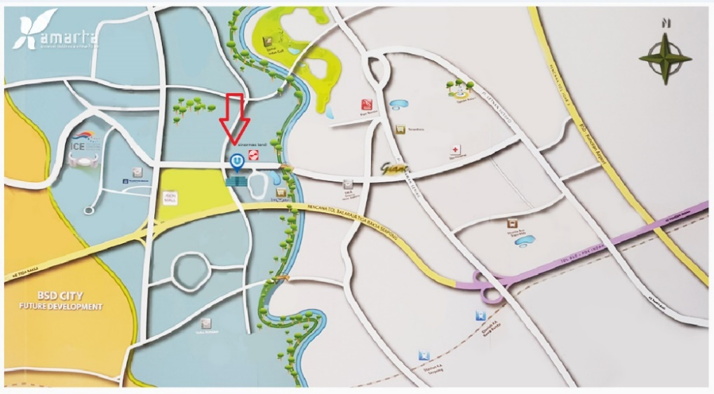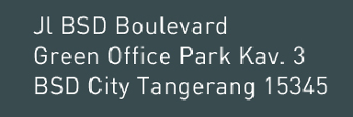
Schedule of Shuttle Bus:
Pick Up Point |  |  | Time | Pick Up Point
Morning Session
1. | Rawabuntu – Grha Unilever |  | 8:45 | At the front of STIKBA, approximately 20m to the nearest gas station
 |  |  | 9:00
 |  |  | 9:15
Afternoon Session
2. | Grha Unilever - Rawabuntu |  | 11:15 | At the front of Grha Unilever – East Lobby head to Rawa Buntu Station
 |  |  | 11:30
 |  |  | 11:45

Tangerang, 22 October 2019
PT Unilever Indonesia Tbk
Board of Directors

